**Ideation Phase**

**Brainstorm & Idea Prioritization Template**

|  |  |
| --- | --- |
| Date | 19 September 2022 |
| Team ID | PNT2022TMID37600 |
| Project Name | Customer Care Registry |
| Maximum Marks | 4 Marks |
| Team Members | D.Lokesh Reddy  CH.Santhosh Reddy  E.M.Anjunath Goud  k.krishna kishore |

**Step-1: The Problem Statement**

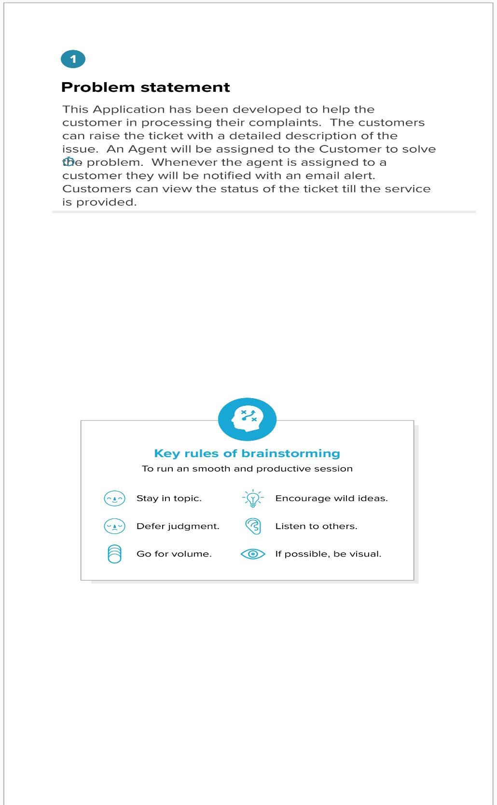

**Step-2: Brainstorm, Idea Listing and Grouping**

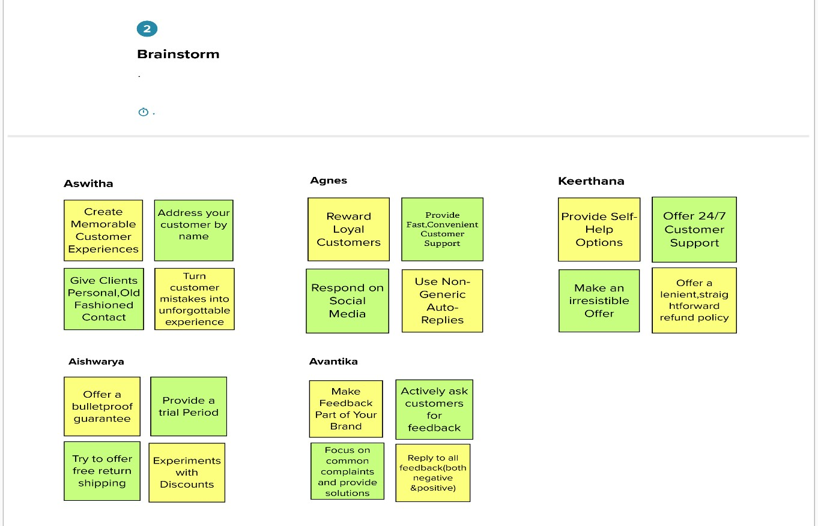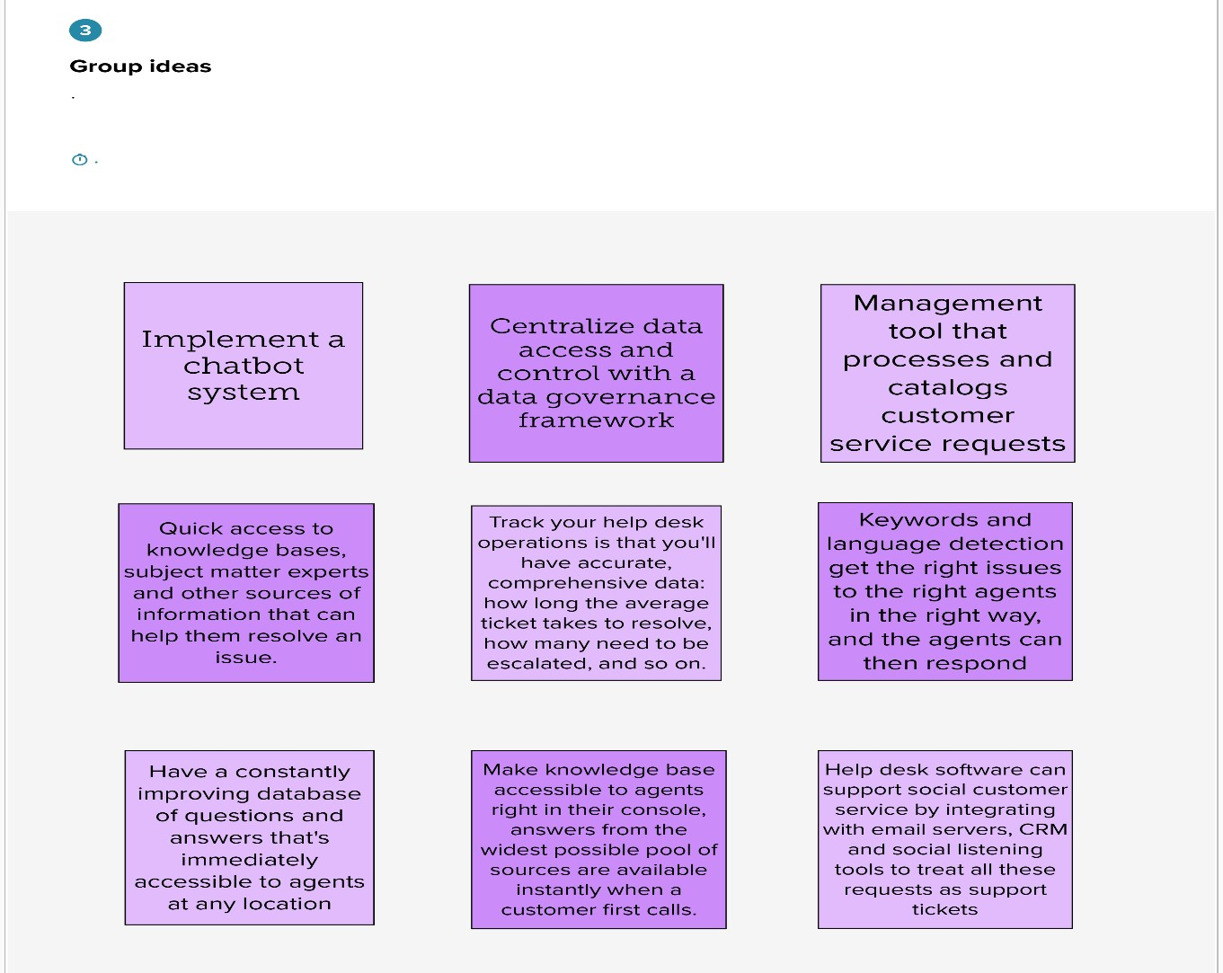

**Step-3: Idea Prioritization**

